**Q. 1 What are the new tags added in HTML5**

HTML 5 introduced too many new tags to expand facilities of HTML. Some of the new tag are as below.

**Structural and Semantic Elements:**

* + <article>
  + <section>
  + <nav>
  + <header>
  + <footer>
  + <main>
  + <figure>

1. **Form Elements:**
   * <datalist>
   * <keygen>
   * <output>
2. **Media Elements:**
   * <audio>
   * <video>
   * <source>
3. **Interactive Elements:**
   * <details>
   * <summary>
   * <dialog>
4. **Scripting and Data:**
   * <canvas>
   * <template>
   * <script>
   * <noscript>
5. **Enhanced Text Elements:**
   * <mark>:
   * <time>

**Q. 2 How to embed audio and video in a webpage?**

Embedding audio & video is one of an additional attractive facility for any web site.

**Audio Code :**

<!DOCTYPE html>

<html>

<body>

    <h2>Tu Hi Re... An Audio Song</h2>

    <audio controls>

        <source src="Tu Hi Re.mp3" type="audio/mpeg">

    </audio>

</body>

</html>

**Audio Output :**

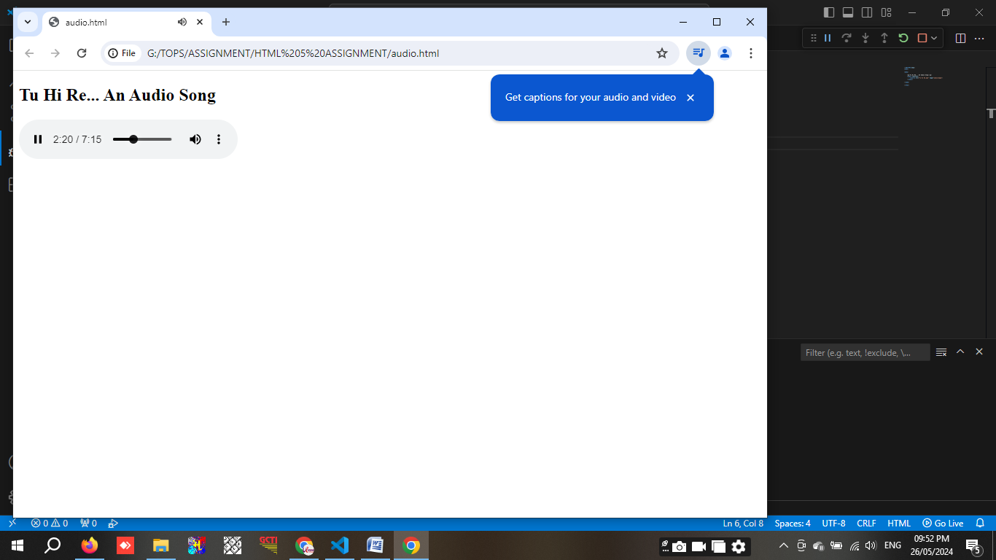

**Video Code :**

<!DOCTYPE html>

<html>

<body>

    <h2>Spider Web... Video</h2>

    <video width="640" height="480" controls>

        <source src="spider.mp4" type="video/mp4">

    </video>

</body>

</html>

**Video Output :**

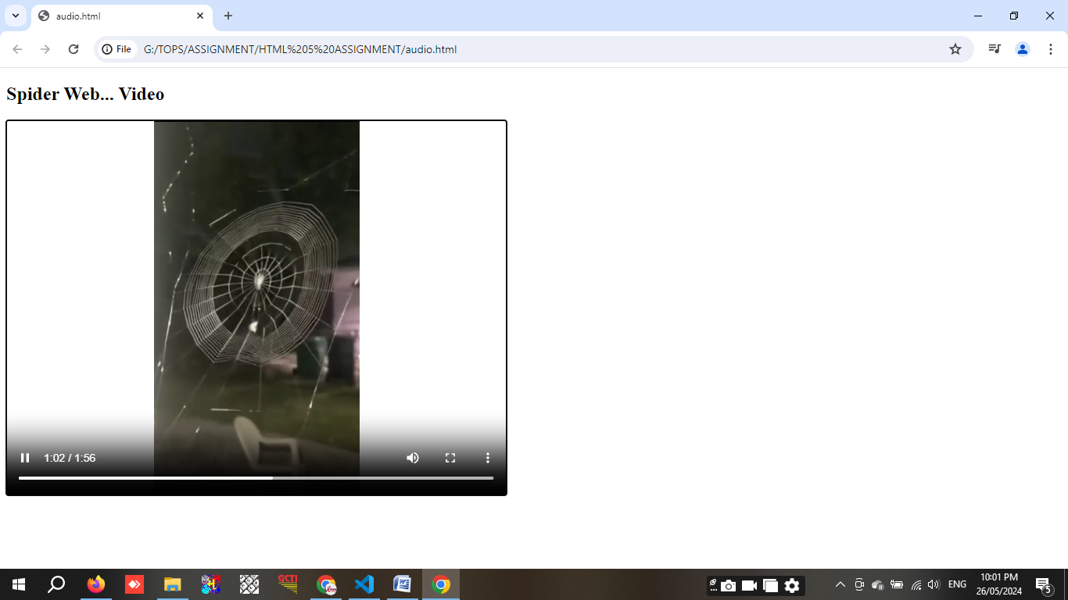

**Q. 3 Semantic element in HTML5?**

Semantic elements are used to improve the readabliti of the code. For Ex.,

**<header>**  It usually contains headings, logos, or other introductory information.

**<nav>**  Used to defines a set of navigation links.

**<main>**  Specifies the main content of a document.

**<article>**  Represents a self-contained composition in a document, page, application, or site.

**<section>**  Defines sections in a document, such as chapters, headers, footers, or any other sections of   
the document.

**<aside>** It's often used for sidebars.

**<footer>**  Defines a footer for a document or a section.

**<time>**  Represents a specific period in time.

**Q. 4 Canvas and SVG tags**

The HTML **<canvas>** element is used to draw graphics, on the fly, via JavaScript.

**<canvas> Code :**

<!DOCTYPE html>

<html>

<body>

<canvas id="myCanvas" width="200" height="100" style="border:3px solid #000000;

background-color: yellow;">

Your browser does not support the HTML canvas tag.

</canvas>

</body>

</html>

**<canvas> Output :**

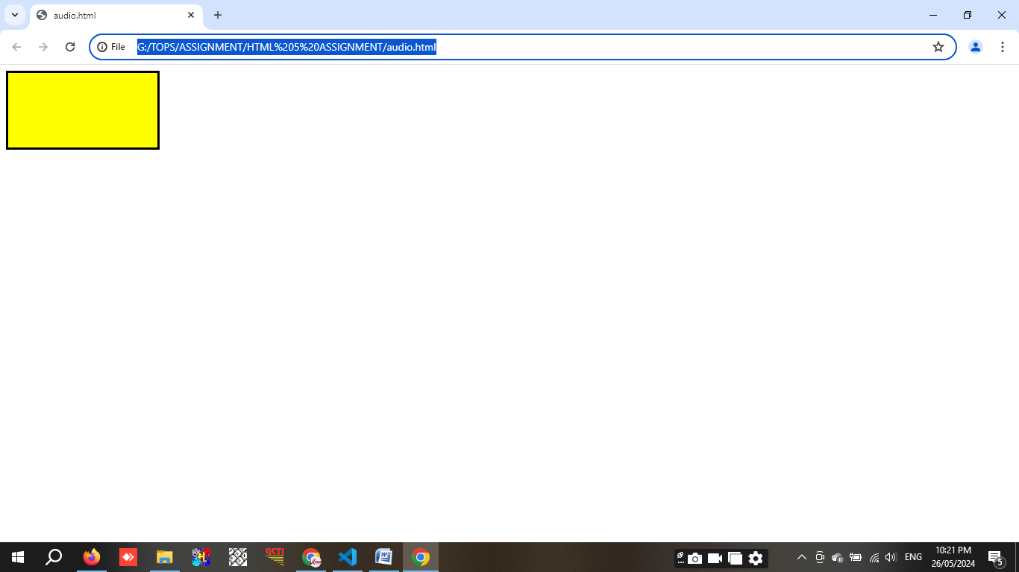

The HTML **<svg>** element is a container for SVG graphics.

**<svg> Code :**

<!DOCTYPE html>

<html>

<body>

    <svg width="500" height="500">

        <circle cx="150" cy="150" r="140" stroke="red" stroke-width="4" fill="skyblue" />

    </svg>

</body>

</html>

**<svg> Output :**

